Franklin Public Library Board Meeting
Feb.11, 2021, via Zoom

- Call to order, 6:36 pm
- Roll call, taken by Teresa Natke. Present: Susan Stevens, Franklin; Rick David, Franklin; Teresa Natzke, Clawson; Janice Cherkasky, Scottsdale, AZ; Susan Pepper, Franklin; Robin Rosen, Franklin . Absent: Kim Greidanus
- Approve Agenda: Rick David made a motion to approve the agenda, Janice Cherkasky seconded it. All approved.
- Approve minutes from January meeting: Janice Cherkasky made the motion to approve; Susan Stevens seconded it. Roll call was taken and all approved.
- New Business:
a. Janice told that she attended the Friends of the Franklin Library meeting. She reported on their plans for October Fest (schedeuled for Oct. 8, 2021) and their desire to fund additional seating for the Reading Garden. There is adequate money in the Friend’s accounts for both projects.
Janice then led a discussion regarding other potential areas of support for the Library. This included a desire for more seating capacity via new chairs and a cart to store and transport these chairs. Additional mention was made of acquiring items to be loaned out to patrons for their use outside on the green and the need for replacement bookcases. As has been done in the past, the Library Director will present a “wish list” at an upcoming Board meeting for review and discussion prior to formally submitting the list to the Friends for their consideration of funding.
b. Causes supported by the library - what is the process? Susan Stevens suggested it may be helpful to have a policy put in place regarding how requests for support/sponsorship by the Library be handled. Teresa will investigate if other libraries have a policy.
c. Purchasing process when expending public funds. Recent Board action was taken to accept a bid for professional services related to our survey project without seeking three competitive bids. Since this project was below a minimum amount of $10,000, as long as a statement of support for sole sourcing is submitted and reviewed by the Board, the Library can engage such services without competitive bidding. Susan Pepper will prepare the appropriate sole sourcing support document in this case.
6. Old Business:
Resident Survey Update: Background research and first draft of what the survey might include will be sent to all after tonight’s meeting for review and comments by the Board and responses are asked to be submitted within one week. While Ann will choose the exact wording of the survey document, based on her expertise as a data scientist, Board members should feel free to offer suggestions of topics, programs and other feedback. The Board review needs to be completed withing one week.

Menorah placement on Library property: After further research by the Library Director, the Village Clerk and Village Counsel, it was ultimately determined that the Library facilities and property are owned by the Village. As such, they will take responsibility for dealing with this matter.
Additionally, based on this research, there is no current agreement between the Library and the Village of Franklin. In the 70’s, there was a variety of actions including a lease, an agreement to sell the building and property to the Library by the Village, a new lease, which was regularly revised. At present, any prior lease agreement has long expired. Rick will initiate a discussion with the Village Council to enter into a formal lease (or sale) agreement to properly document the ownership, use and related responsibilities for the Library facilities. Rick also suggested that we have an updated appraisal of our library building and contents so that we can obtain proper replacement value insurance. He will speak to the Village administrator and their risk management professionals.
7. Treasurer’s Report: Rick reported on the January 2021 monthly report. TLN was a major cost. Rick also recently conducted a mid year budget review with Teresa and noted that we are generally in good shape with our budget but we are a bit over budget in terms of collections at this time. Rick made the motion to approve the financials; Janice seconded it. Roll call was done by Teresa and all approved.
8. Librarian’s Report: Teresa reported that our circulation numbers have gone up recently. We also send out over 600 books on a monthly basis to other libraries
Teresa brought up the discussion of opening in March. Among the items considered – 1)About 1/2 of the libraries in our network are currently open for “Grab and Go”; 2)The infection rate is low for Oakland County 3)The daily number of new cases is still high. 4)The CDC’s new policy on double masking as 95% effective. 5)Birmingham schools will reopen on March 15 6)Capacity in our building would need to be capped at 4 people, including the staff member.
After much discussion, it was agreed that effective March 15, 2021, the Library will reopen its doors, require that patrons ‘double mask’, not allow computer usage, and permit short visits only. Our librarians will continue to bring books out to those who have requested books on hold and wear a shield when they leave the cubby. The library facility will be sprayed each hour with Lysol.
Susan Pepper left the meeting at 7:42 due to another commitment.
New Resident Initiative : Teresa followed up on this with the Village President and indicated that the Library would like to be a participant, as appropriate.
The director also mentioned that one of the employees violated Library policy by soliciting signatures on petitions on Library grounds during her employment hours. All employees were reminded that this is not a permissible activity.

9. Maintenance: New garden furniture. Robin Rosen reported that she and Kim met to discuss purchasing furniture for the garden. The first step will be to meet with the garden designer to determine how many seats make sense for the space, and where to best place them. Then, decisions about material, style, color, and vendor will be made, with the input of the board. This information will be presented at the March meeting.
Susan Stevens asked that we move the November meeting to November 18.
Meeting was adjourned at 8:10. Our next meeting will be March 11, and it will continue to be a Zoom meeting.
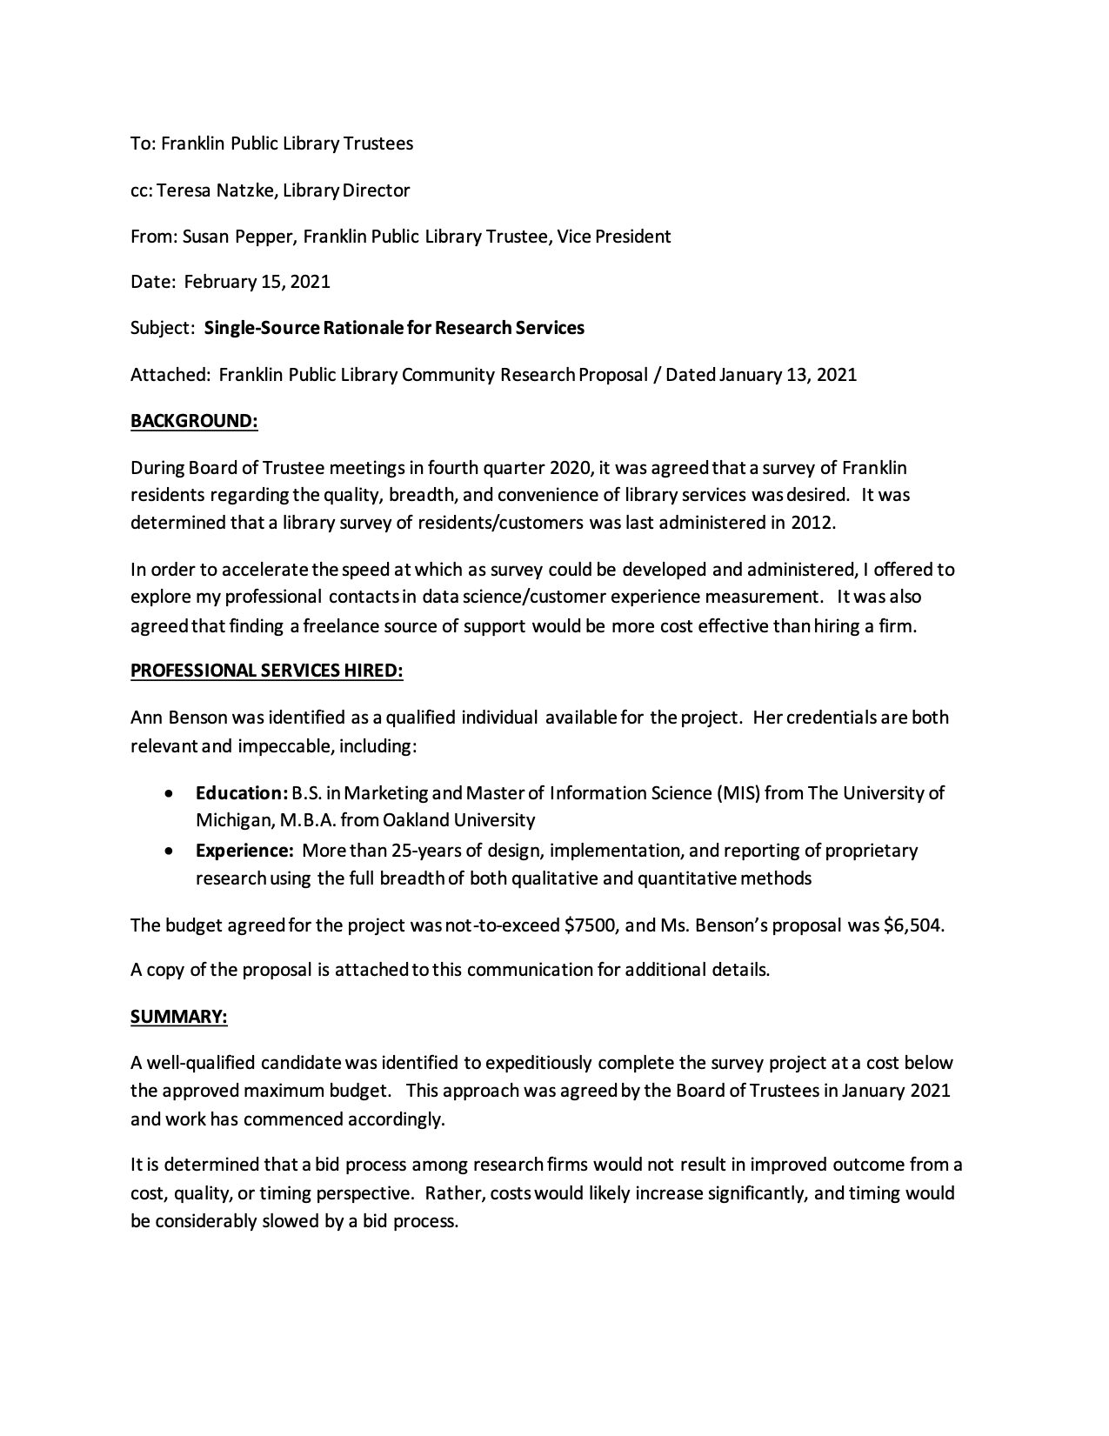
Respectfully submitted by Robin Rosen, secretary

